Sum Unique Counts

# Reference documents

<http://vnu10.blogspot.com/2011/01/mdx-grand-total-sub-total.html>

<https://blog.crossjoin.co.uk/2013/05/29/aggregating-the-result-of-an-mdx-calculation-using-scoped-assignments/>

# Step 1

Inside the DSV, in each fact table, create a Named Calculations for each distinct count.

DiagnosisFact has two distinct counts:

* [Diagnosis - Encounter - Unique Count]
* [Diagnosis - Patient - Unique Count]

We need to create a Named Calculation for each (please choose your own naming convention):

* DiagnosisEncounterUniqueCountAsSum
* DiagnosisPatientUniqueCountAsSum

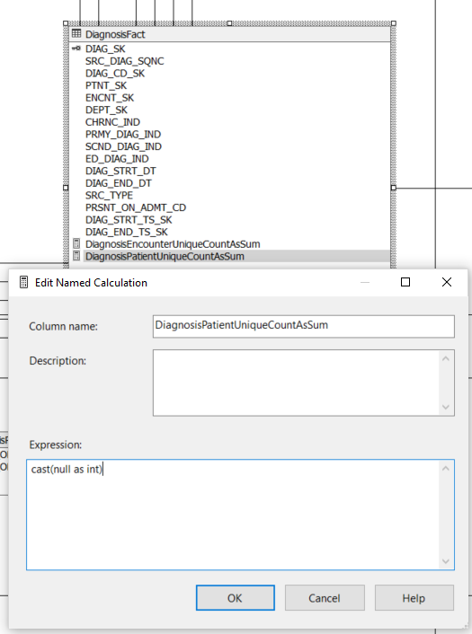

The “Expression” accepts any valid SQL statement. The CAST is used to convert the NULL to the desired data type.

# Step 2

